Part 1

1. Describe the energy store changes when a rocket firework is lit, goes up in the air and then falls back
to the ground. (4)


2. A cyclist is braking hard to avoid a collision.
Describe the energy store changes as the bicycle and rider decelerate to a stop. (3)

3. When a battery stops working people often say the energy has been used up. Explain why this statement is not
correct. (2)

4. The Sankey diagram shows the simple energy store transfers for a car.
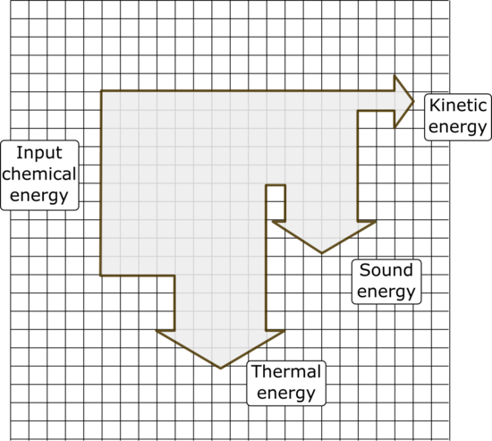

Chemical energy from the petrol = 20 000 J

- Calculate the amount of useful energy
transferred by the engine. (1)

- What is the total amount of “wasted” energy
in the system? (1)

5. An eagle has a mass of 4 kg and is flying at a velocity of 35 m/s. Calculate the kinetic energy of the bird. (3)

6. The spring on a car wheel extends by 0.05 m when the wheel goes down a pothole in the road.

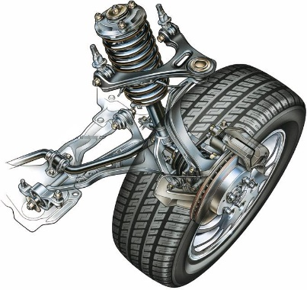
spring

E = ½ k e²

If the spring constant is 20 kN/m, calculate the elastic potential energy in the spring when it is extended. (2)

7. A 48 kg person diving off a cliff has 3500 J of stored gravitational potential energy. Calculate the height of the cliff (3)

Part 2

1. The diagram represents the energy transfers for an oil-fired power station.
Generator
Turbine
Water and steam
Oil

Energy transferred as movement
Useful energy out
X
Energy transferred as heat

- What is the useful energy out? (1)

- In what form will energy be “wasted” in this process? (1)

- What useful energy store is represented by the box labelled X? (1)

2. Loft insulation reduces heat loss from a home.

Loft insulation can be made out of many different materials.

Give two properties of the insulating material that will affect the amount of heat lost through the roof. (2)

3. Describe two ways you could increase the efficiency of a household central heating system. (2)
Part 3

1. Name four renewable and four non-renewable energy resources. (2)
Energy Resources
Renewable resources | Non-renewable resources

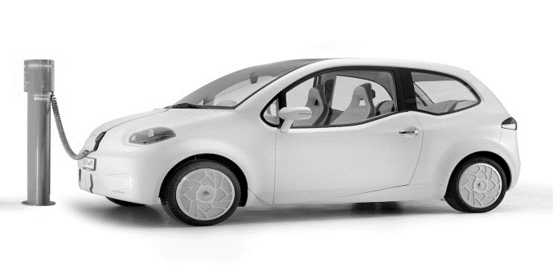
2. An electric car uses no fossil fuels to turn its motor.

The manufacturer claims that this car does not contribute to carbon dioxide emissions into the atmosphere.

Explain why the manufacturer's claim is not true. (3)

3. Explain why fossil fuels are considered to be a more reliable energy resource for electricity production than the
use of wind turbines. (3)

4. Name an appropriate energy source for each of the following uses and briefly describe how it is used for
this purpose. (3)

Use | Energy source | How it is used
Producing electricity
Transport
Heating a hospital

5. Worldwide agreements to reduce CO₂ emissions are intended to slow down climate change. Describe how CO₂ emissions contribute to climate change. (4)

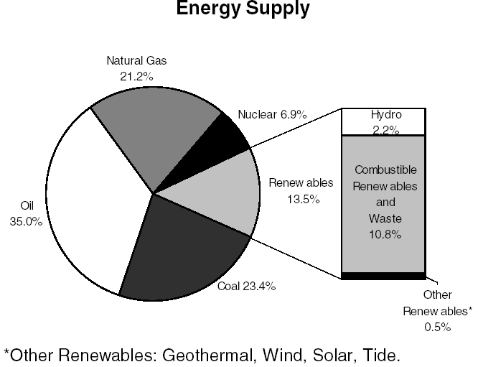
6. The chart shows the world’s energy resources usage for 2015.

Discuss the likely changes to the worlds energy supplies over the next 50 years. (6)

